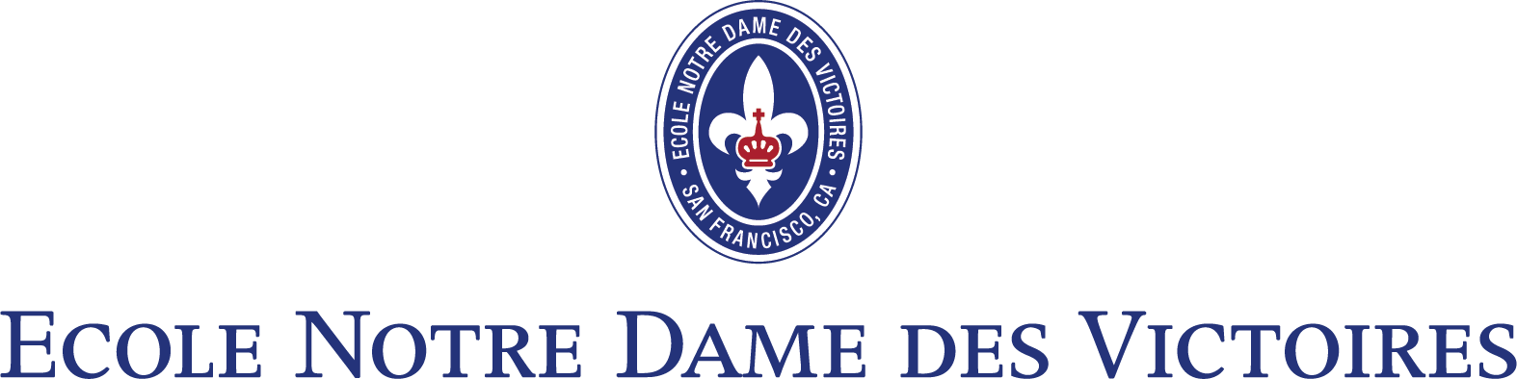

Community Events

Dear Friends,

We have a number of exciting events scheduled at NDV, and we hope that you will be able to attend those that interest you to experience the spirit of the NDV family.

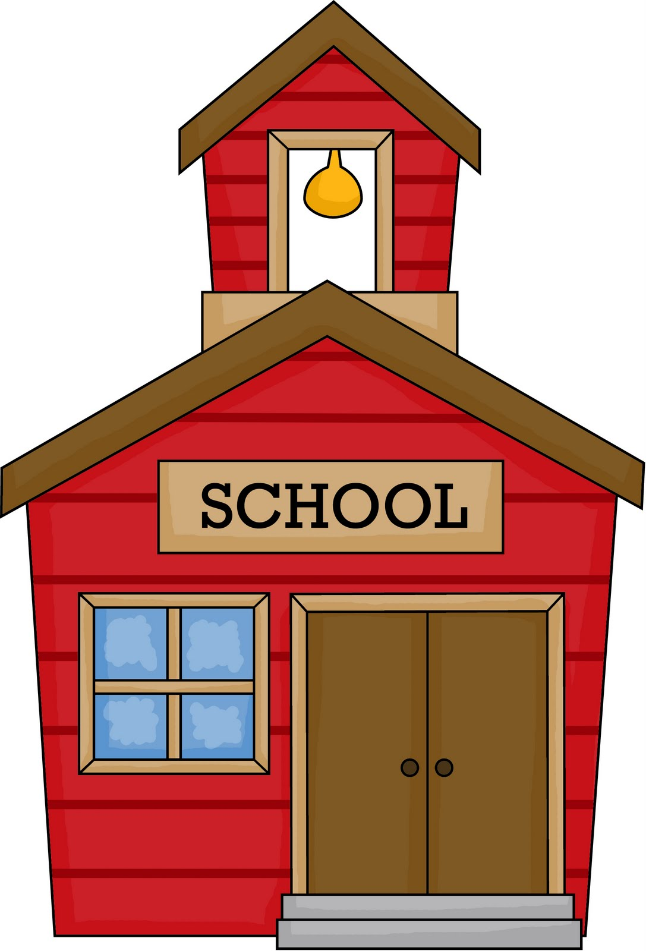
TK & Kindergarten Evening Open House ~ Thursday, October 3 | 5:30 – 7:30 pm
Prospective parents (adults only,) join us for a presentation by the principal, school tours, and a light
reception at Ecole Notre Dame des Victoires, 649 Pine Street. All NDV faculty and staff will be present.
RSVP to admissions@ndvsf.org.
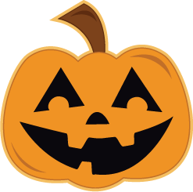
NDV Halloween Carnival ~ Saturday, October 26 | 4:00 – 8:00 pm
NDV Parents’ Association sponsors a “frighteningly” fun Halloween Carnival that is held in the school
auditorium. Costumes encouraged. Please email admissions@ndvsf.org for tickets.
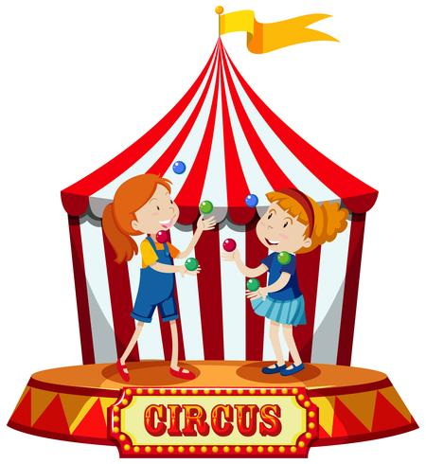
69th Annual Bal de Paris “Cirque Magnifique” ~ Saturday, November 9 | 6:00 to midnight
Please join us for our Gala, an evening of dinner, dancing, live and silent auctions at the Ritz Carlton
Hotel San Francisco. Please call the school office (415.421.0069) for tickets and more details.
Christmas Music Program ~ Friday, December 13 | 2:15 – 3:15 pm
Please join us for NDV‘s annual children’s music performance to be held in the school auditorium. Each
grade, Kindergarten through eighth will be performing.

